# Test Instructions for the MCBMini board

# Install/Acquire Tools Needed

## 1. Have the AVR programmer ready

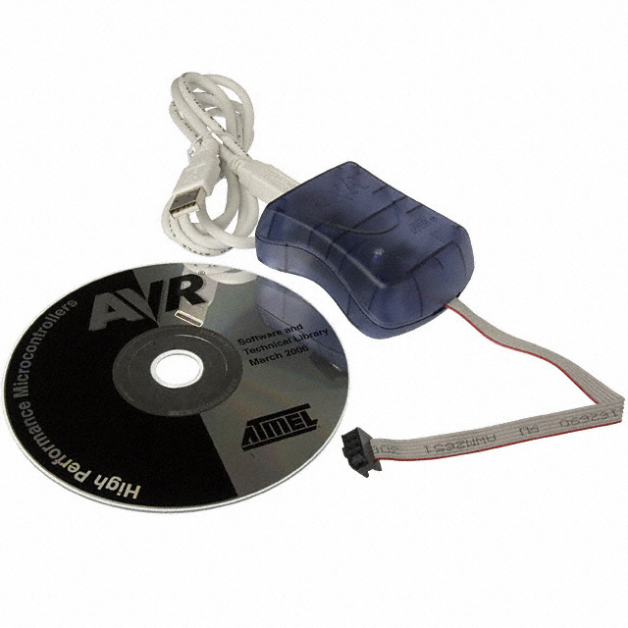

I use the AVISP mkII which can be purchased from DigiKey at this link:

<http://www.digikey.com/product-detail/en/ATAVRISP2/ATAVRISP2-ND/898891>

## 2. Install the AVR Studio 6 environment (~800Mb)

You have to provide a name and email here, a download link will be sent to email

<http://www.atmel.com/System/BaseForm.aspx?target=tcm:26-44514>

## 3. Unzip the test kit (TestSuite.zip)

Make sure to unzip this into an easily accessible directory such as “C:\TestSuite”

## 4. Install Java

To test to see if java is currently working on your system then open a Command Line (Start->Run-cmd [Enter]). From the CMD prompt type “java”, if it says “Command not found” or something similar then you either don’t have java installed OR the system PATH variable doesn’t point to where Java is installed.

Help on setting the system PATH variable properly can be found here:

<http://java.com/en/download/help/path.xml>

If Java isn’t currently installed on your system, download it from here and install it:

<http://www.java.com/en/download/index.jsp>

# 2. Power Testing and Flashing

## 1. Power device

Set a power supply to 12V and limit its output current to about 150mA

Connect the board as shown in picture and make sure the power supply doesn’t show a short circuit.

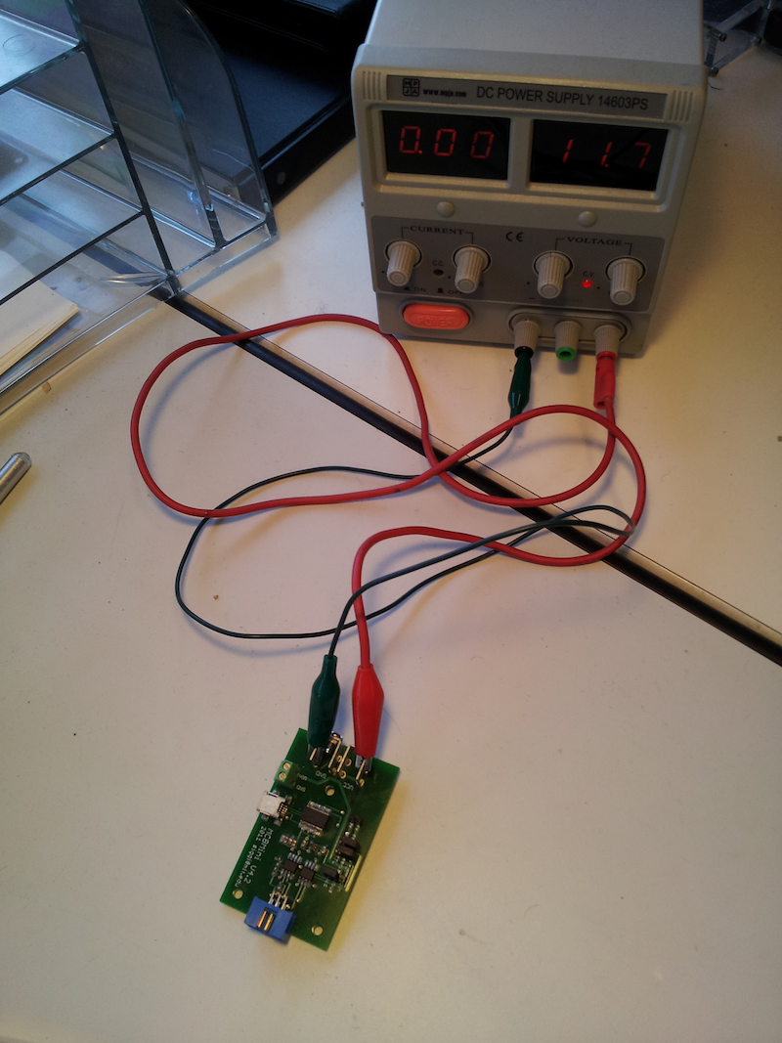

Make sure that the jumper caps are in this following setting:

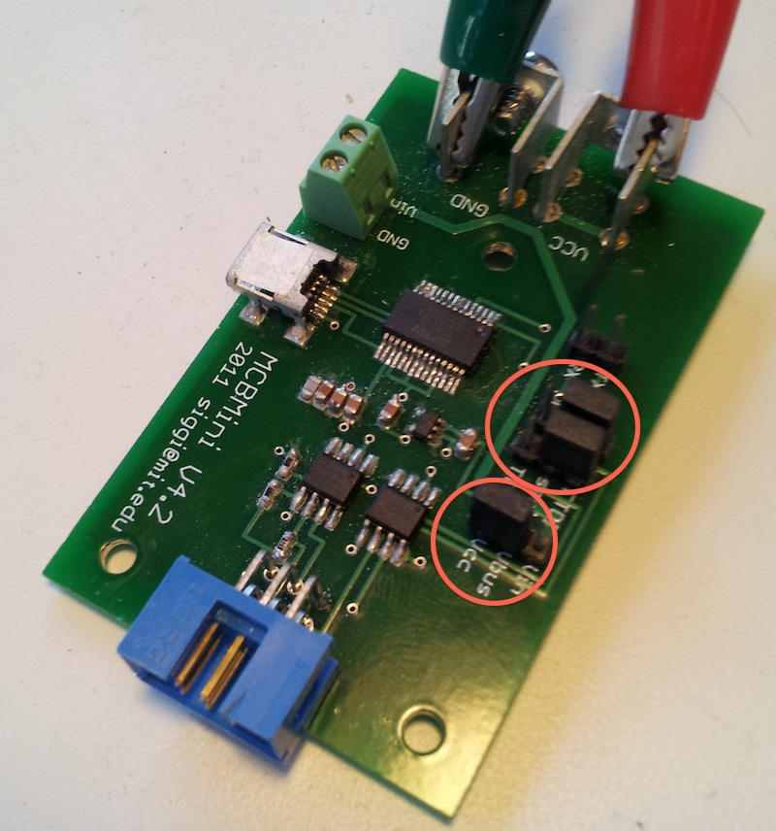

Connect the MCBCom board to the compyter with a USB cable and look for the COM_PORT_NAME in the “Device Manager”

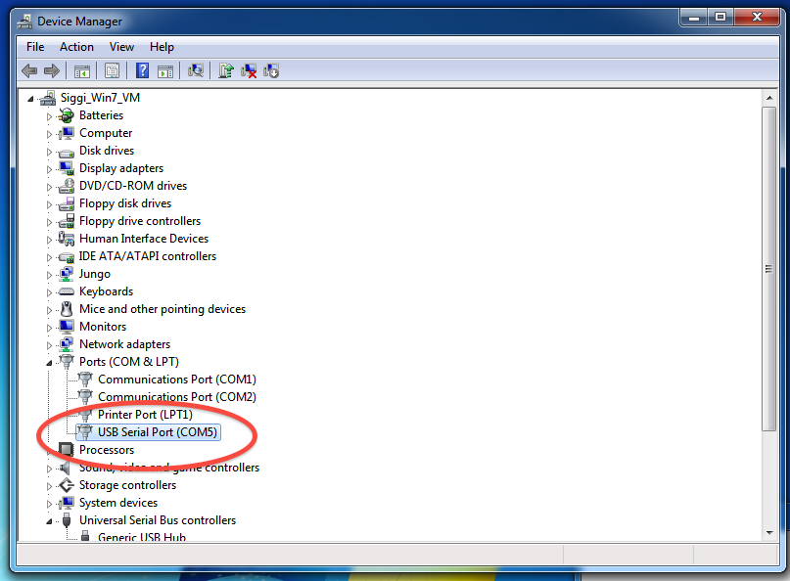

## 2. Upgrade AVRISP mkii firmware

Connect AVRISP mkii programmer via USB to computer. Allow Windows to find the right driver for this programmer (should happen automatically if you installed Atmel Studio 6 prior to connecting the programmer)

Open Atmel Studio 6 and go to Tools->AVR Tools Firmware Upgrade

Here you will be allowed to upgrade firmware on the programmer if needed.

## 3. Flash MCBMini

Connect the ribbon cable between blue connectors on the MCBCom and MCBMini board. **Make sure the orientation of the ribbon cable connectors is the same !!** Make sure that the power supply doesn’t short-circuit.

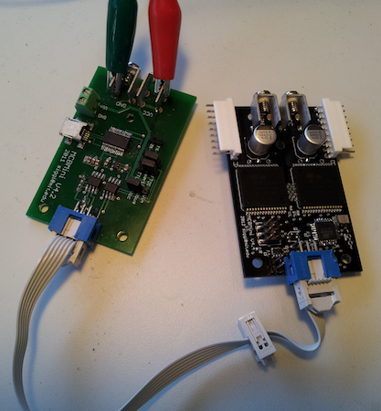

Once the MCBMini board is powered from the MCBCom board, connect the AVRISP mkII programmer to the board such that the ribbon cable of the programmer goes over the board (see picture)

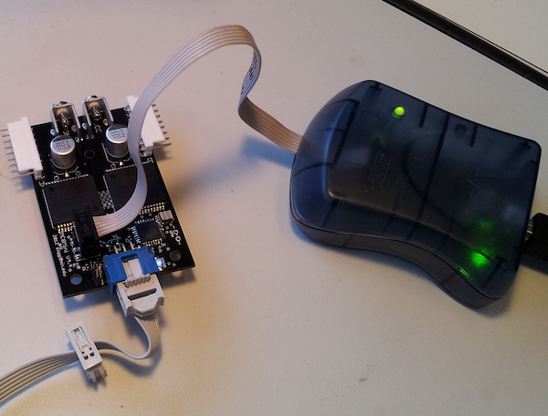

Open up the Atmel CMD prompt (Start->Atmel->Atmel CMD Prompt) and move to the test directory:

“cd C:\TestSuite”

Now flash the board:

“program.bat”

The expected output is:

"Programming fuses"

Write completed successfully.

"Programming firmware"

Programming completed successfully.

# 3. Communications and driving a motor

## 1. Test Communications

Once the board is programmed, you can run a communications test:

“communications_test.bat NAME_OF_COM_PORT”

Here is the expected output of a successful run

12:26:55-MCBMini: MCBMini: Parsing configuration file "motor_config.xml" of version: 1.1

12:26:55-MCBMini: Waiting for all boards to report their firmware, IDs: 1:

12:26:56-MCBMini: Motorboard 1 reports firmware version: 30

12:26:56-MCBMini: All boards have reported their firmware, lowest firmware version: 30

SUCCESS !! Firmware value: 30

## 2. Test controlling a motor

If this test is successful then we will attempt to drive a motor.

Connect the power terminals of the MCBMini and MCBCom with as is shown in picture, also connect a motor to the MCBMini board (which channel doesn’t matter)

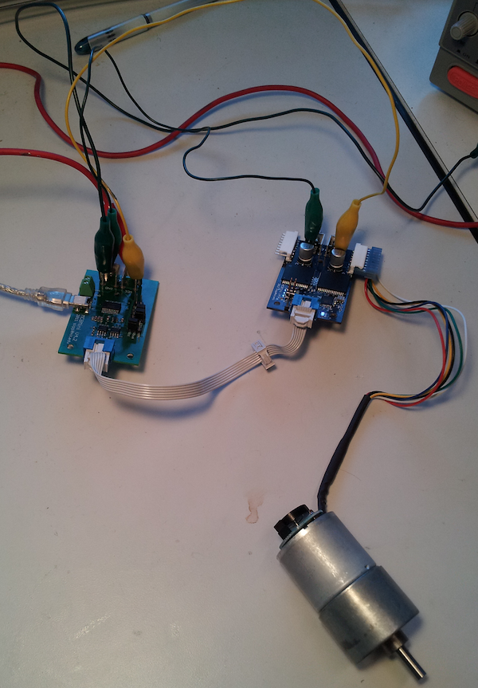

Now change the current limit of the power supply to be higher (anything above 1A should be fine)

Run the driving test:

“driving_test.bat NAME_OF_COM_PORT”

If successful, the motor should now move according to a sinusoid wave.

# Congratulations! You seem to have a working MCBMini board !!